Lab 3

1-restructure your code to use variables
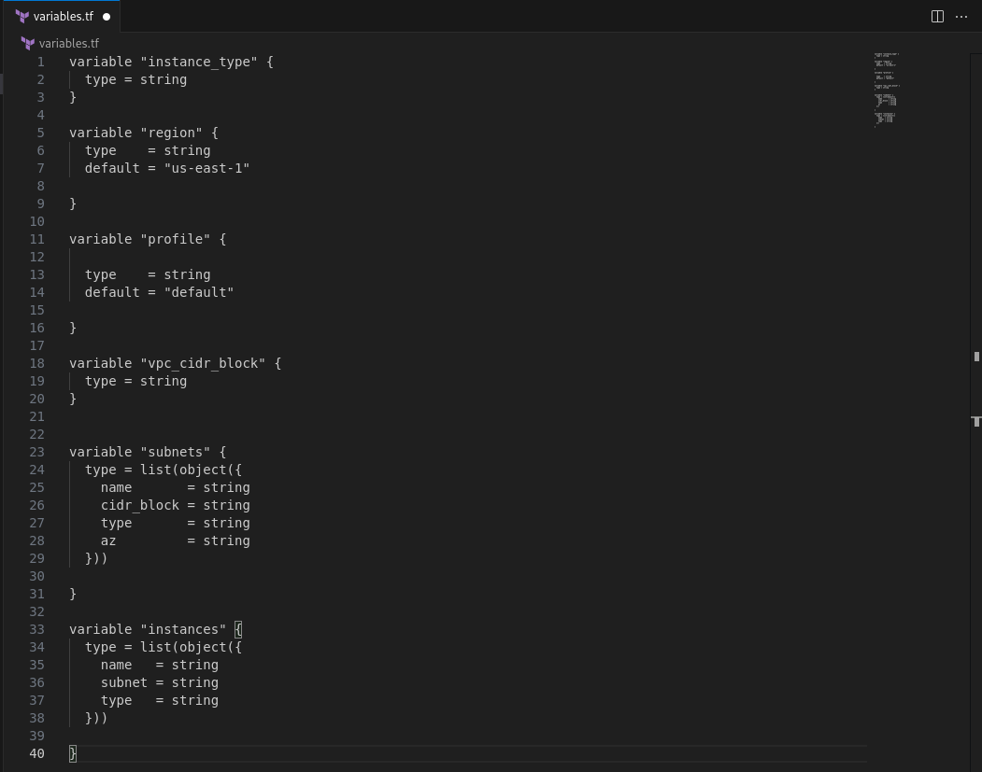
2-create all subnets with single resource using for_each
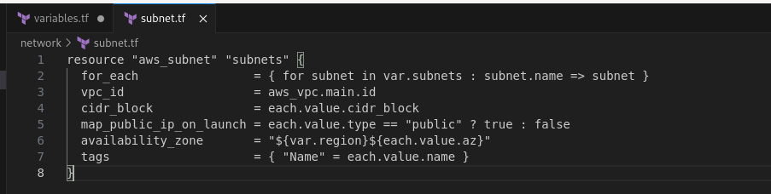

3-make condition on subnet resource based on type (public or private) to control
map_public_ip_on_launch
4-create all ec2s with single resource using count

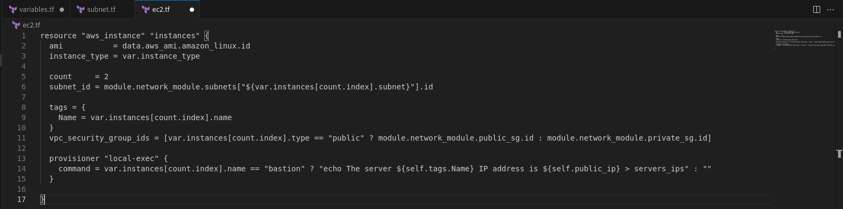
5-create two workspaces dev and prod
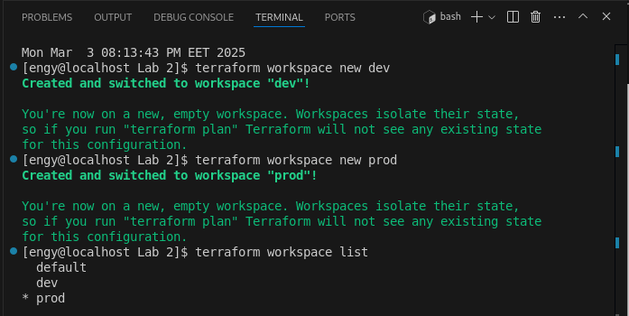

6-create two variable definition files(.tfvars) for the two environments
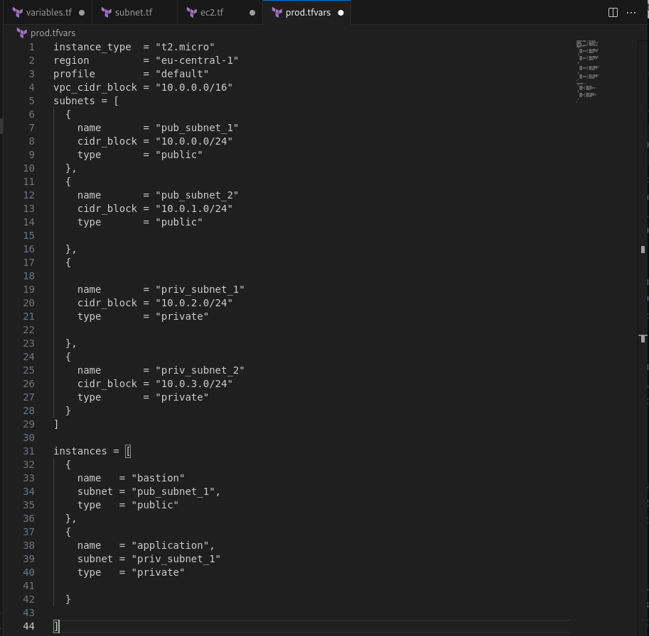

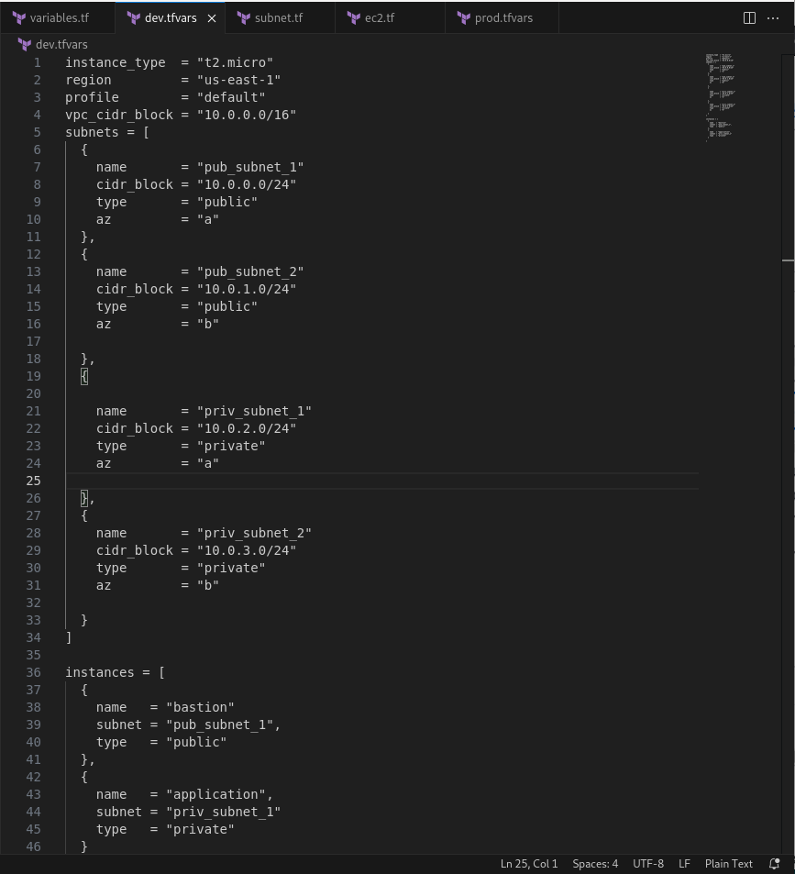

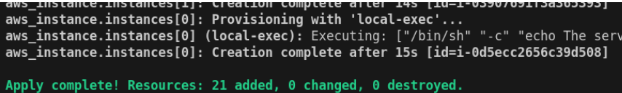
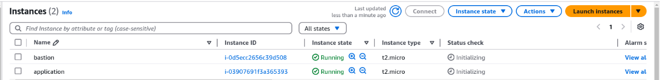

8-run local-exec provisioner to print the public_ip of bastion ec2

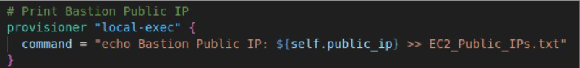
9- upload infrastructure code on github project
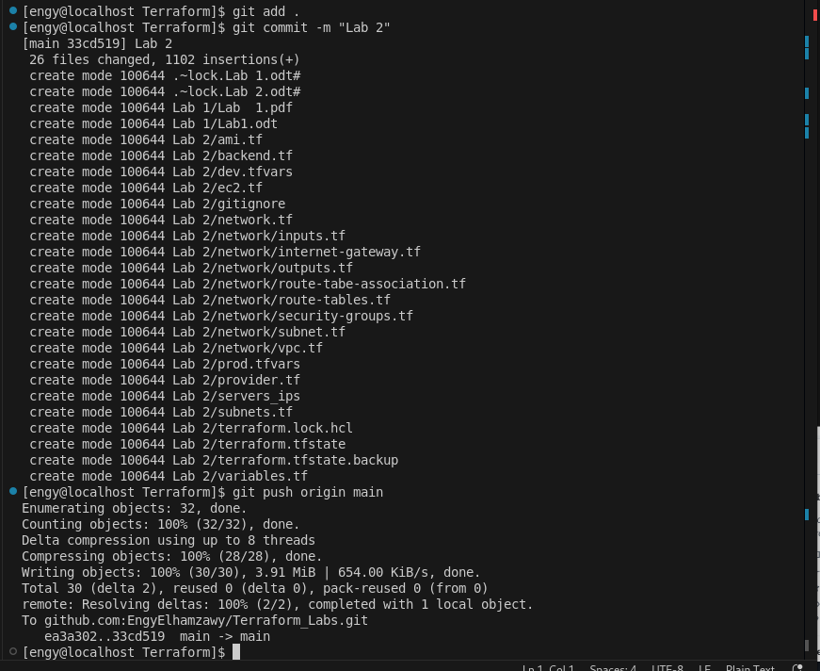
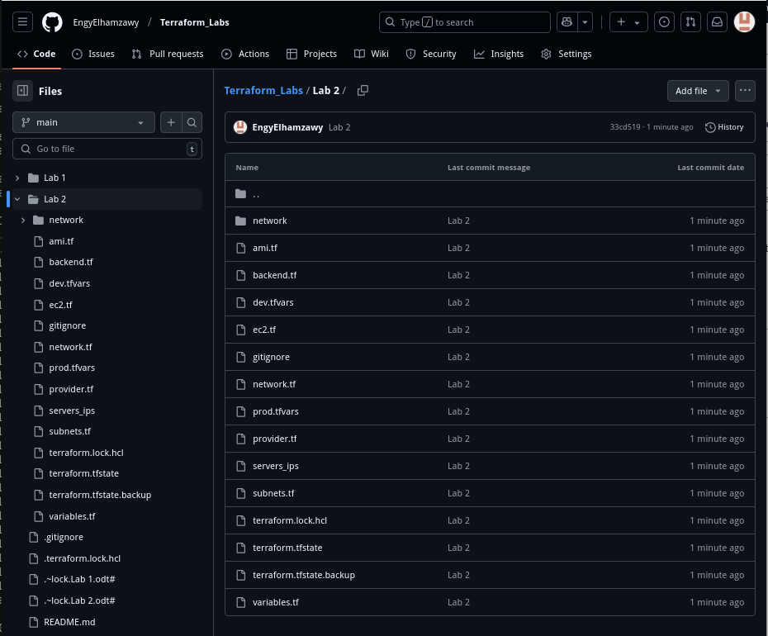

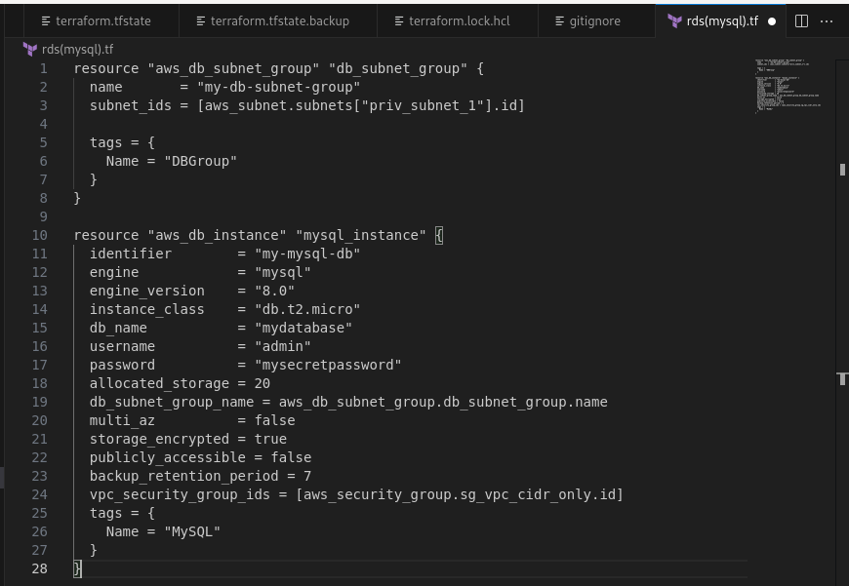
10- create rds(mysql) in private subnet

11- create elastic cache redis in private subnet

